Employee Motivation: A Complete Guide
Student’s Name
Institution
Course
Professor’s Name
Date

Executive Summary
Organizations are struggling to develop the most effective ways to improve performance and productivity, which influences the firm's overall profitability. While many organizations fail to consider the primary resource that can help them build their enterprises' values, some organizations understand the critical role that employees play. They design properly managed employee motivated programs or system that helps them keep up with the strategic human resource management. This paper provides a comprehensive guide on employee motivation, types, importance, and how to achieve it. Using secondary resources, this paper explores how organizations can create and maintain a sustainable employee motivation system.

Employee Motivation: A Complete Guide
Introduction
Every business aims at creating a sustainable business management process that can help achieve success. Employees are a critical part of the organization, and yet, in some organizations, they are not given the necessary recognition. This promotes high employee turnover and reduces the morale of the remaining staff. Employee management is a complex yet purposeful process that helps the organization create an effective and sustainable working environment and atmosphere for employees. Many managers do not understand how to create a sustainable working environment because they can relate how employee performance affects overall organizational productivity. Research studies have connected employee performance and productivity with employee motivation.
Previous Approaches
A significant body of theory and empirical evidence exists to confirm and attest to employee motivation's influence on employee productivity. According to Ganta (2014), employee motivation plays a critical role in the organization. It serves as the root from which the organization's progress and downfall can emanate (Ganta, 2014). Jain et al. (2019) further agree that employee motivation is the critical factor that drives the capacity of association. In the current globalization age, building the capacity of association is critical in helping the organization achieve great success and increase its productivity, which translates to higher profitability. Employees are the common determiner in this entire scenario because everything starts with them. As such, employers must understand the important role that employee motivation plays in ensuring that employees have the moral and the zeal to commit to their work and give it the best. As Lorincová et al. (2019) explain, business sustainability is the ultimate goal in the business management process. Employees are part of the primary factors that lead to sustainability in the business process. Therefore, managers need to understand their role in creating a sustainable business process while considering the important role of employees in influencing the business management process changes. Employee motivation can help promote the company's performance positively by creating and building the values of the firm and its success. This is a complex process, but it is also purposeful if the organization needs to improve its performance and productivity. Ganta (2014) further argues that employee productivity is an inseparable concept from employee motivation. Employee motivation helps to satisfy their aspirations, needs, and interests as well as stimulates their action in a more desirable way that seeks to achieve the organizational goals.
Even though scholars disagree on the most effective strategies to employ in motivating employees, they all agree that employee motivation needs to be regularly undertaken to improve its effectiveness. Ganta (2014) explains that many organizations understand the importance of employee motivation, but failure to implement a regular system makes it difficult for them to realize the potential benefits associated with this tool. Jain et al. (2019) assert that employee motivation is one of the primary tools that the organization can use to improve its productivity. Many organizations, even those that understand the importance of employee motivation, disengage employees with ineffective or low motivation.
New Findings
Importance of Employee Motivation
Employee motivation has a wide range of benefits, including increased productivity, which translates to improved profitability for the organization. As Ganta (2014) explains, motivated employees can lead to improved productivity, which allows the organization to achieve higher levels of production. Employees who are not motivated are characterized by low production, wasting time, and personal pressure. This, in a business environment, results in the wastage of both time and resources that would have been used to do something productive.

Importance of Employee Motivation
Employee motivation further improves their commitment to work. According to Jain et al. (2019), when employees are motivated at work, they can put their best effort into their tasks. They get the zeal and energy to work and complete their assigned tasks on time.
Employee motivation is also associated with improved employee satisfaction. No one wants to have employees who come to work to do the same thing every day. When employees are not motivated, they lose interest in even coming to work. This lost morale can be brought back by satisfying some of their desires. Some of the employees are facing severe financial pressures or personal problems. An unmotivated environment can further increase their stress about the problem they are dealing with.
Types of Employee Motivation
Intrinsic Motivation
Intrinsic motivation is the internal motivational factors. These are motivations that emanate from within the individual staff. Even though they are dependent on individual staff, managers can also help to improve intrinsic motivation. The best way to improve employee intrinsic motivation includes giving employees positive feedback (Panait, 2020). However, it should be noted that positive feedback can also be a demotivating factor. Therefore, it should be used in moderation.
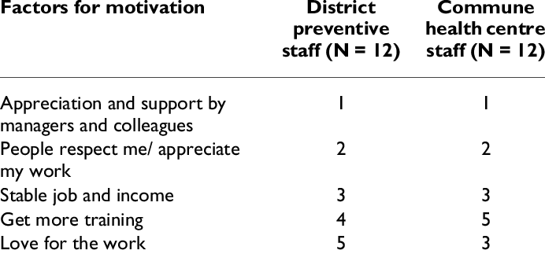
Intrinsic Motivation Factors for Motivation (Source: Google.com)
Another strategy to improve intrinsic motivation is through praises. This can be done immediately after the employee has done something to the expectations or beyond the expectations. These two techniques can empower employees and helps them understand what the employer expects of them.
Extrinsic Motivation
Extrinsic motivation refers to the motivation that is stimulated by external factors, which include rewards and recognition. Research has shown that extrinsic rewards can enhance an employee's individual willingness to learn and acquire a new skill set to improve its performance. Extrinsic motivation can include bonuses, awards, perks, and recognition (Bawa, 2017). Reward value of the goal is one of the most effective ways to motivate employee extrinsically. Reward involves providing a meaningful reward to the employees at the end of a great or successful assignment. This is not a bribe but a token of appreciation to keep the employees motivated and appreciated for offering their best services. Another significant extrinsic motivation is professional development. This is one of the commonly used motivation strategies. Professional advancement is important for every employee. Having this in mind can help design a career growth system for employees.
Conclusion
Employee motivation plays a significant role in promoting employee's commitment and morale to give their best at work. Without motivation at the workplace, the organization may face major risks of incurring great losses. An unmotivated employee cannot perform well. He or she would not give the best effort or even work hard to achieve the organizational responsibilities. A motivated employee, on the other hand, has the reason to commit to his or her work, which helps the organization achieve its goals. Motivated employees influence the overall performance and productivity of the organization. Therefore, managers need to design effective strategies to help achieve employee engagement because an engaged employee is emotionally committed to the organization and its course.

References
Bawa, M. A. (2017). Employee motivation and productivity: a review of literature and implications for management practice. International Journal of Economics, Commerce and Management, 12, 662-673.
Ganta, V. C. (2014). Motivation in the workplace to improve the employee performance. International Journal of Engineering Technology, Management and Applied Sciences, 2(6), 221-230.
Jain, A., Gupta, B., & Bindal, M. (2019). A study of employee motivation in organization. International Journal of Engineering and Management Research (IJEMR), 9(6), 65-68.
Lorincová, S., Štarchoň, P., Weberová, D., Hitka, M., & Lipoldová, M. (2019). Employee motivation as a tool to achieve sustainability of business processes. Sustainability, 11(13), 3509.
Panait, C. A. (2020). Study of Employee Motivation in Organizations. Global Economic Observer, 8(1), 114-119.

